Direct Radiology Promotes Drs. Brian McElaney, Mark Harshany and Mark Takaki to Newly Created Medical Director Position

Shift supports company’s growth and commitment to providing hands-on teleradiology leadership

COEUR D’ALENE, IDAHO – Nov. 30, 2015 – Direct Radiology, a leading provider of teleradiology solutions to radiologists and radiology groups throughout the United States, has announced that Brian McElaney, M.D., Mark Harshany, M.D. and Mark Takaki, M.D. have been selected to serve as the company’s new medical directors.

In these newly created leadership roles, Harshany, McElaney and Takaki will be responsible for overseeing radiology staff, reviewing new radiologist or reappointment files, participating as members of the Medical Executive Team alongside other company leaders, serving as Direct Radiology committee members for important topics such as ICD-10, HIPAA compliance and more to maintain Direct Radiology’s excellence and further company growth. With the addition of these positions, Direct Radiology looks toward the future and continues to accommodate the ever-growing industry.

“Direct Radiology was founded as a radiology partnership, bringing the best in our field together to provide hands-on teleradiology leadership and unparalleled service,” said Lawrence Bub, Direct Radiology co-founder and managing partner. “These three radiologists already brought diverse and extensive expertise to our team. In this new role, each will play an important part in maintaining and evolving Direct Radiology services and supporting the company as we continue to meet the needs of our customers across the U.S.”
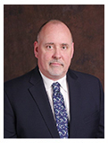
Brian McElaney, M.D. has been in practice as a board-certified radiologist for more than 25 years. He graduated from Duke University and attended medical school at St. Louis University on a U.S. Army Health Professions Scholarship. After an internship with a Boston University program, he completed a diagnostic radiology residency at Tripler Army Medical Center in Honolulu, Hawaii. After residency, he fulfilled his military obligation as a radiologist at U.S. Army hospitals in Stuttgart and Heidelberg, Germany. After honorable discharge from the Army with the rank of Major, he completed a fellowship in abdominal imaging at Duke University Medical Center. For 19 years before joining Direct Radiology, Dr. McElaney worked as a private practice radiologist in hospitals in the St. Louis area and in Massachusetts. He has held numerous leadership roles including group president, and served for many years as Section Chief of Body Imaging at a large community hospital in Illinois. Dr. McElaney looks forward to transitioning into this new role and values Direct Radiology’s model, which allows for more personal connections with other radiologists and company leaders.

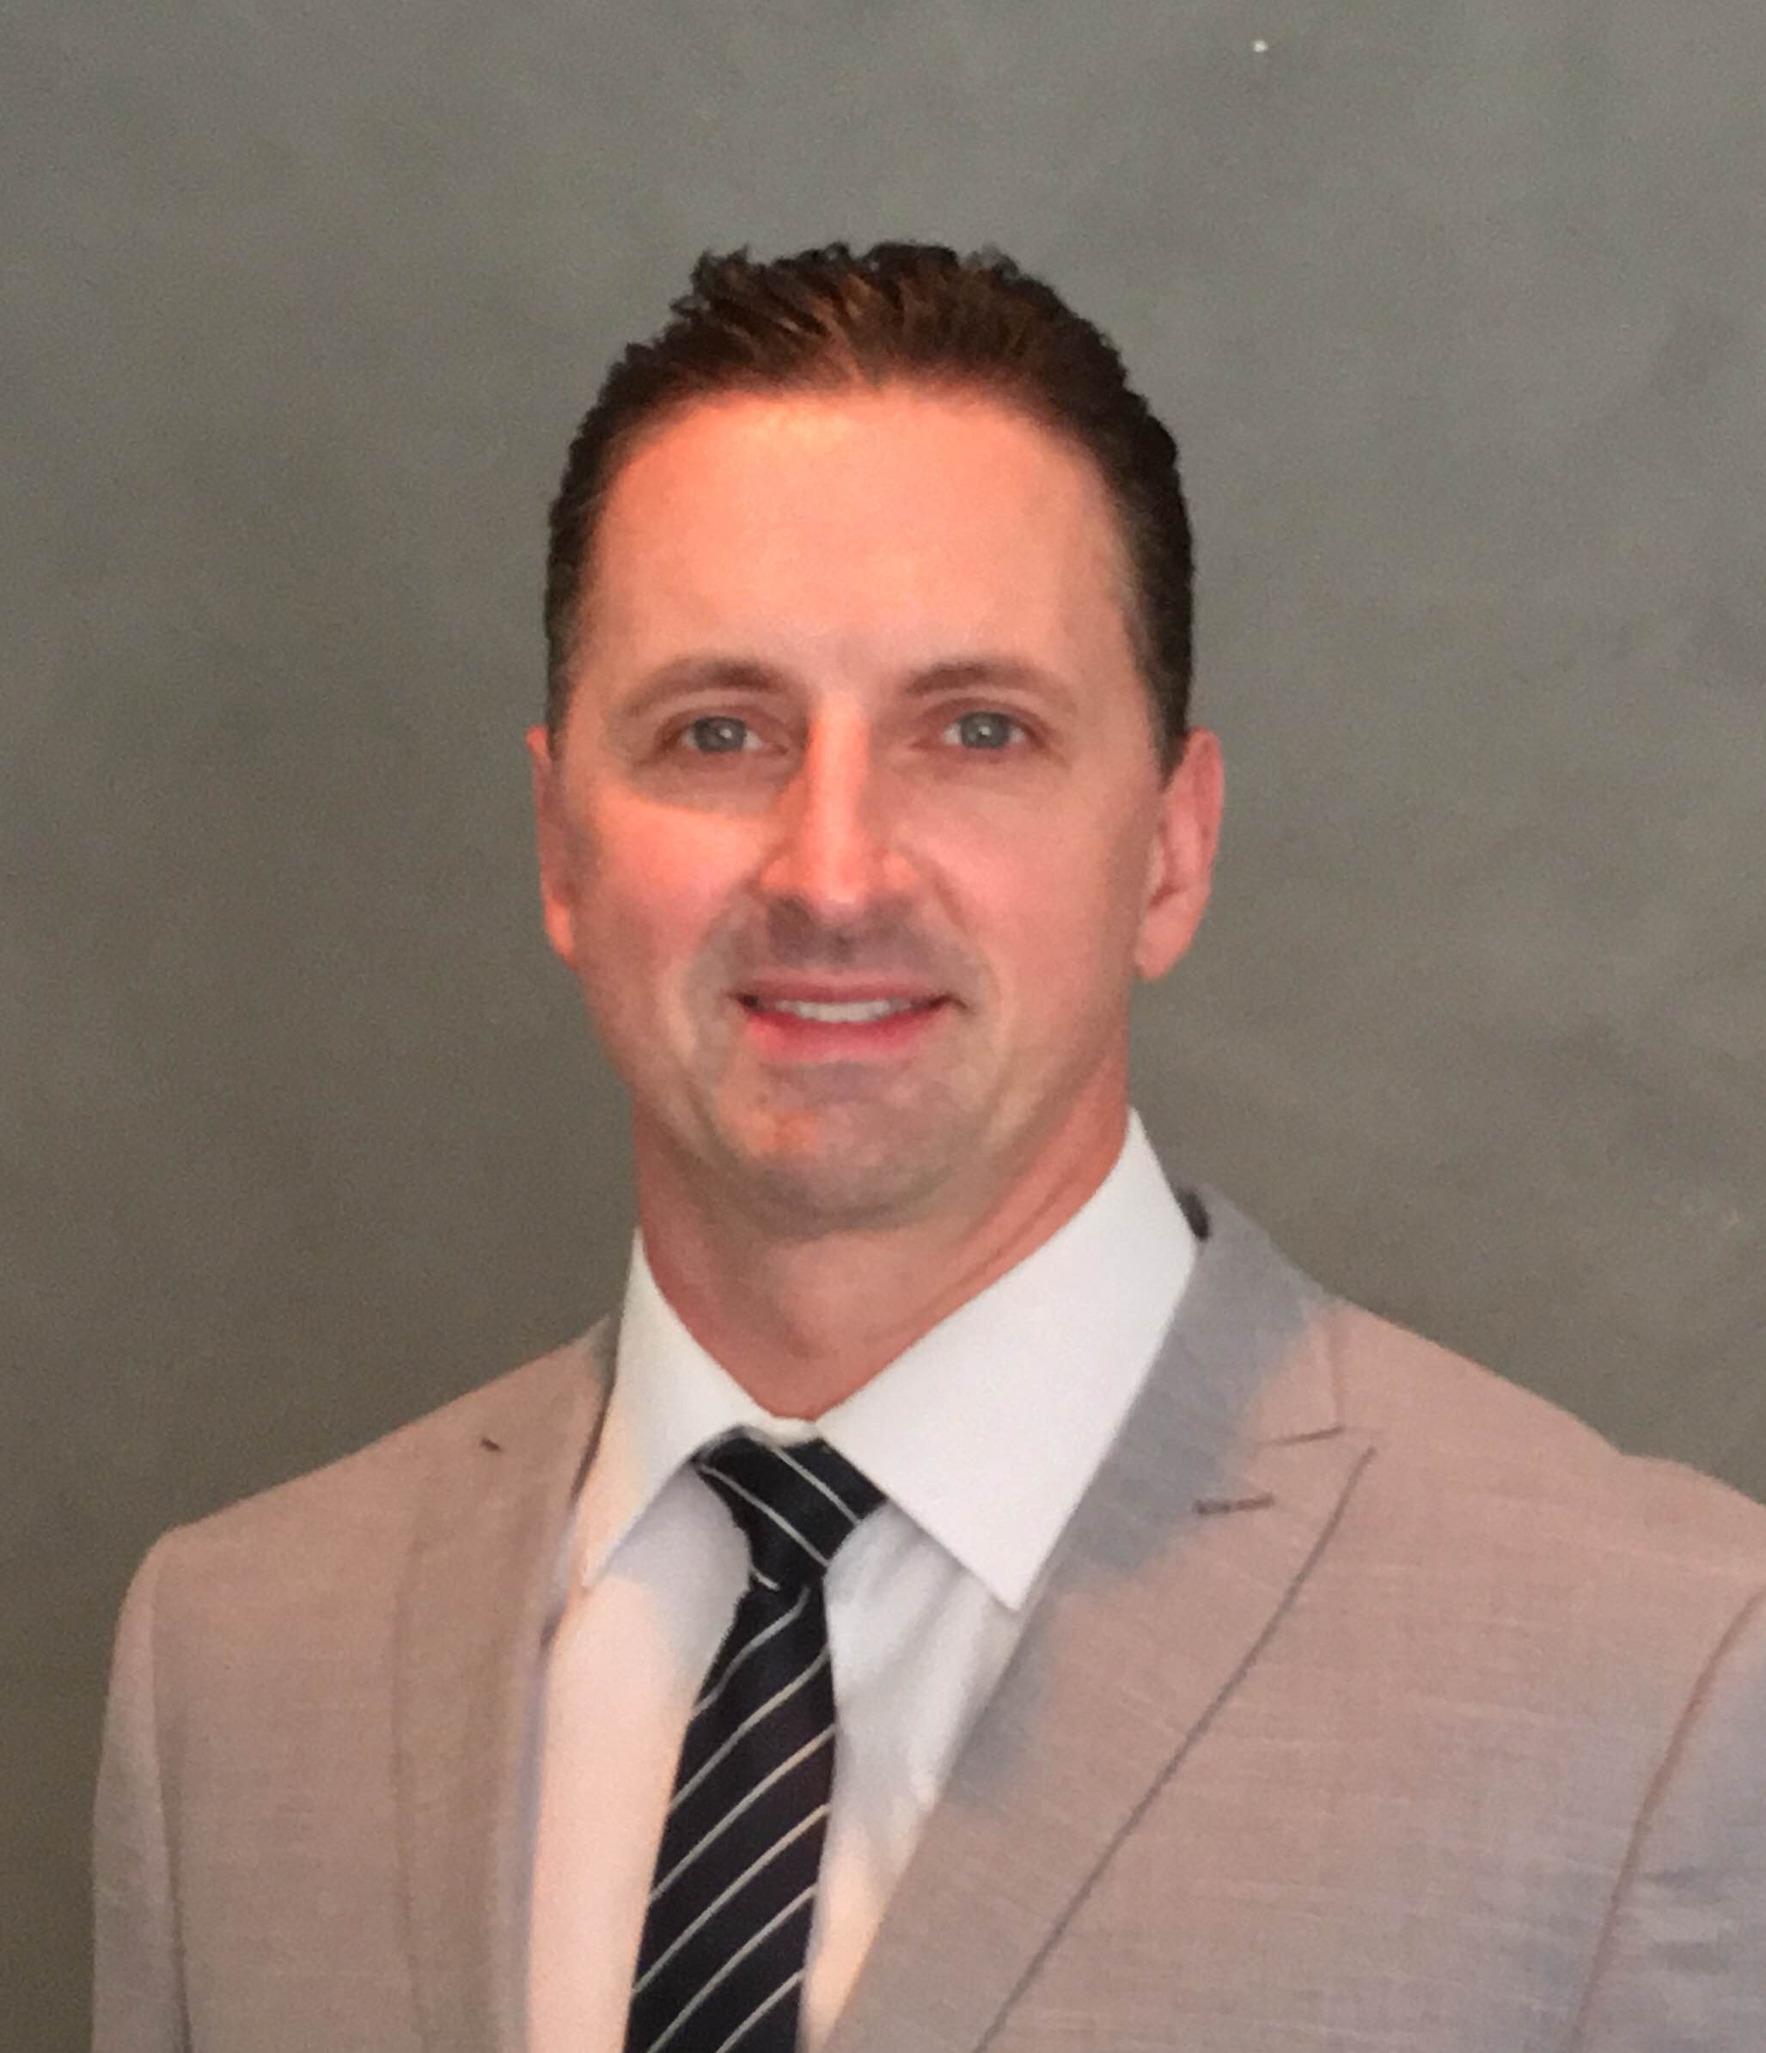
Mark Harshany, M.D. comes to the Direct Radiology team with a range of both military and private sector experience. He served as a Medical Corps officer for the U.S. Army as Chief of Radiology for Moncrief Army Community Hospital and also as a Diagnostic Radiologist at a variety of practices for more than seven years. Dr. Harshany received his undergraduate degree from the Florida Institute of Technology and attended medical school at F. Edward Hébert School of Medicine. Following that, Dr. Harshany completed a transitional internship at Brooke Army Medical Center and completed his residency at the San Antonio Uniformed Services Health Education Consortium. Dr. Harshany sees this new role as an opportunity to support the vision and goals of the senior leadership and helping to shape and achieve the strategic focus of Direct Radiology moving forward.

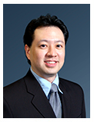
Mark Takaki, M.D. was raised on the island of Oahu, where he attended undergraduate and medical school at the University of Hawaii. He completed a transitional internship and diagnostic radiology residency program at Virginia Mason Medical Center in Seattle, Washington. He was then fellowship trained in body imaging at the University of Washington. During his fellowship, Dr. Takaki began his teleradiology career contracting with vRad before joining the Direct Radiology team nine years later. In 2010, he and his family relocated back to Honolulu, where he currently resides. Dr. Takaki looks forward to joining the leadership team, contributing to the strategy of the organization and having a more active role in Direct Radiology’s growing day-to-day operations.

About Direct Radiology
Founded in 2012, Direct Radiology is a physician-owned and operated teleradiology practice working in close partnership with more than 180 facilities across the country. Unlike most teleradiology companies, Direct Radiology’s full-time physicians are partners and stakeholders in the practice with a focus on client service and high-quality patient care. Learn more at www.directradiology.com.

For more information:
Nicole Yost | Fyn PR for Direct Radiology | Nicole@FynPR.com | 970-776-9980

###

