7/6/2016 V\latching DVDs on special goggla helps children at Wolfson Children’s Hospital get throug h MRIs vvlthout sedation | jacIsonviIle.com

I4OME/NEWS
Watching DVDs on special goggles helps children at Wolfson Children's Hospital get through MRIs without sedation
By Char lia Patton Tue, Jul 1, 2014 @ 4:33 pm | updated Tue, Jul 1, 2014 @ 4:54 pm

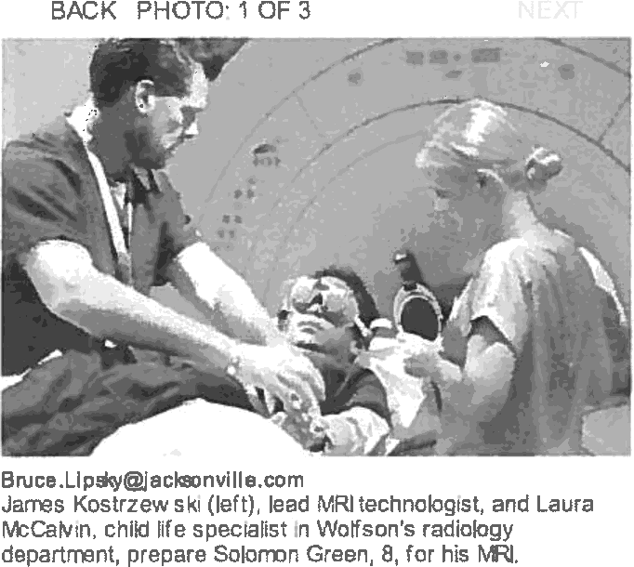
Lying motionless inside a narrow tube listening to strange noises for 30 minutes or longer is nobody’s idea of a good time. But that's what is necessary when undergoing an MRI (magnetic resonance imaging), a medical procedure that offers images of what’s inside someone’s body.

Getting a child to remain still during an MRI can be quite challenging, especially if the child has a
short attention span or is claustrophobic, said Laura McCalvin, a child life specialist in the radiology department of Wolfson Children’s Hospital. As a result, many children have had to be sedated by an anesthesiologist before undergoing an MRI.
Slideshow: MRI video goggles in action
Now Wolfson and McCalvin have a new tool that is diminishing the need to sedate children prior to an MRI. Instead, the child is fitted with Cinemavision Googles, allowing the child to watch a movie on DVD during the procedure. The system includes headphones that mostly shut out the noise being made by the MRI scanner.
For 8-year-old Solomon Green, the movie of choice was “The Tooth Fairy,” a 2010 comedy in which a hockey player, played by Dwayne ‘The Rock" Johnson, is forced to spend a week as the tooth fairy. Solomon chose the movie from a collection of DVDs that Wolfson maintains. But children can also bring a favorite DVO with them, McCalvin said.
Solomon, who recently finished the second grade at Oak Hill Elementary School, had been experiencing pain in his foot and in his head. The MRI would attempt to find the source of that pain.
Prior to the MRI, McCalvin took Solomon into a training room where she showed him pictures of the MRI scanner.
“We have two really cool cameras back there,” McCalvin told him. “Do you like doughnuts? The cameras are shaped like doughnuts. You'll be kind of like the cream filling in the doughnut.”
McCalvin then asked Solomon: “What is your super important job for your pictures?”

Solomon paused for a moment.
“Just be still,” he said.

http:fjaclsonville.corn/new\s/health-and-fitness/2014-07-01/story\matching-dads-special-goggles-hatps-children-v\olfson 1/3

7/6/2016 Watching DVDs on special goggles helps children at Wolfson Children’s Hospital get throug h MRls without sedaton | jacIsonviIle.com “Awesome,” said McCalvin.
The MRI technician performing Solomon’s scan was Jim Kostrzewski.

Having the Cinema sion Googles has “helped a lot,” he said. “I had an 8-year-old this morning

who was a real nervous Nellie. The goggles helped her get through it.”

The first person to use the Cinemavision Googles after they were installed May 29 was 16-year- old St. Johns resident Dustty Davidson. During an MRI scan of his hip, he watched the 2002 movie “Scooby-Doo.”

“When you’re watching a movie, you're totally focused on that,” he said. “It was like watching TV,
but you weren’t using a TV. You were wearing glasses.”

In addition to using the Cinemavision Googles, Wolfson has a program called “MR-I Am Ready!,” which is geared to helping prepare children ages 6-11 to undergo MRb without sedation.
One week before the child’s scheduled MRI, the child comes to Wolfson, where McCalvin shows pictures of everything the child will see; explains what will happen; and has the child lie in a play tunnel that is about the width of the MRI tube and listen to the clanging sounds of an MRI scanner.
The training “makes it possible to schedule the MRI sooner than would be required with sedation,” McCalvin said.

Charlie Patton: (904) 359-4413

Times-Union/Jacksonville.com Our Network

Visit our Customer Service Center Contact Us/Staff Directory
Times-Union Subscriber Services Times-Union Classifieds Advertising
Discover Jacksonvilte Company Store Company History Archives/Search
sign up for newsletters Mobile 6 apps
Text Alerts nss Needs
Times-Union e-Edition Local Business Directory jobs.jacksonvi1le.com homes.jacksonvi11e.com Legal notices

schools.jacksonvi11e.com Running.jacksonvi1le.com Jax Air News
Kings Bay Periscope Nayport I lirror
Eco Latino Hope Fund

99° 99°
morrow Kz'ida
SpotToumament NewspaperMnEducadon(NIy Times-Union Spelting Bee
High School youmali sm Awards yags Teen Talk

StAugusâne.corn 5avannahNow.com

Jacksonville.com, Florida Times-Union 02015. All Rights Reserved.
http:fjacIsonñlIe.com/ne\xs/health-and-fitness/2014-07-01/story/vmching-d\ds-special-goggles-helps-children-v Ifson U3

